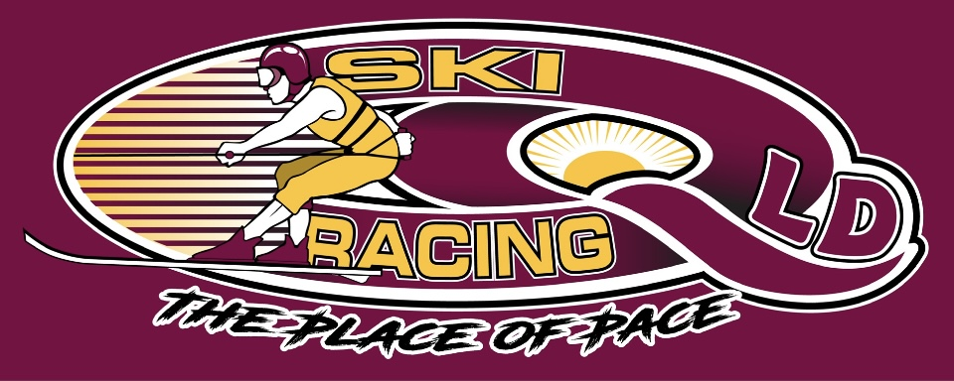

Equipment Checklist for Skiers

It is the duty of the skier or parent to check and inspect all skier equipment prior to racing
each time.

DO NOT TRIAL or USE ANY NEW OR DIFFERENT SKI OR GEAR FOR THE FIRST TIME
UNDER RACE CONDITIONS

Skies
A Ski should be checked for;
- Cracks in timber or laminates
- Ski Fin for straightness or defects
- Bindings checked for loose screws or tears in rubber.

Helmets
A Helmet to be used for Water Ski Racing must have the following requirements:

- To have a finish of Fluorescent Orange
- Appropriately fit the user, the helmet should fit tightly without any gaps between the
Shell and the users head
- A firmly secured Strap and adjusted to be firm under the chin when fastened by a snap
Buckle
- Any fittings mounted to the helmet for neck restraints etc, shall have fasteners
appropriate for the application, not protrude into the inside of the helmet. Fasteners on
the outside must have no sharp edges and no threads protruding past the end of the nut
- (Dome Nuts are preferred)
- Helmet must have SKIER’S name clearly marked on the helmet.

Notes
A properly fitted helmet is vital for the performance of the helmet whilst skiing. Prior to
competing and especially after a fall, the helmet should be checked before use for cracks or
fatigue and replaced if damaged. Faded or damaged helmets will be rejected for use at SRQ
events if deemed not to be up to a good standard.

Ropes and Handles
With competitors not racing for a number of years Ropes and handles are a major concern when it comes to safety as we return to racing.

A rope should be replaced if it;
- Shows any signs of wear
- Has any frays
- Has signs of heat damage or melted in any way
- Has any knots that are unable to be undone
- The age of the rope must also be taken into consideration before use
- When splicing ends on ropes, if the end of the rope is burnt to ease splicing, always cut off
burnt end once done, as the hard, rough end can wear the rope from the inside causing it to
break
- Use a rope that is suitable size for the user, too light and the rope will excessively stretch
and break, too heavy and the rope is more prone to dip and catch water.

Ski Handles
- Regular ski rope is not recommended to be used as part of the handles or
harness and if used, replaced regularly.
- Much stronger rope exists that also resists abrasion better than normal ski rope.
- Take extra notice of wear and tear around the area of the front bar.

Wetsuits
- Should fit the individual wearer correctly and have no tears or holes.
- Ensure appropriate amount of flotation to float the wearer appropriately
- Be of fluorescent color above the waist line.

- Your race wet suit – needs to be tested to see if it will float you whilst your lungs are
exhausted of air & possibly full of water –SRQ will conduct Float Tests prior to all events

- Understand you are placing yourself in a highly dangerous probability of drowning or getting run over if your flotation is inadequate.
- It is likely your helmet & YOU will end up in different locations, you need to be seen.

Other Considerations

- Consider wearing a bright color glove or arm sleeve to enhance the ability for the Observer to see hand signals.

- Complete a warm up routine before skiing. E.g. light jog, burpees, lunges, push-ups,
followed by stretching for all range of movements legs, neck, arms back etc.
Body Flexibility – the more flexible your body is the greater your possibilities are of lessening your injuries in a fall

