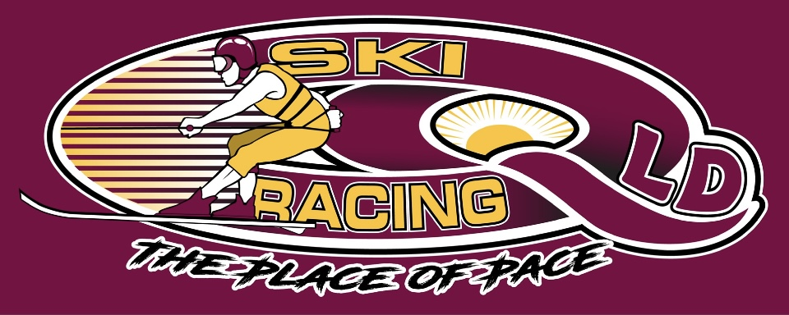

WAIVER AND INDEMNITY STATEMENT OF UNDERSTANDING
WARNING: Water Ski Racing has risks that may cause severe injury or death.
1. Rules of membership and participation: By agreeing to these terms and conditions, You will become a member of Ski Racing Queensland (SRQ). You acknowledge, agree and consent to becoming a member of the Ski Racing Queensland. Upon becoming a member of SRQ, the SRQ constitution will comprise a contract between You and SRQ and You will be bound by it and any by-laws, policies and codes of conduct made under it. You agree You are bound to each subsequent amended version of the SRQ constitution, by-laws, policies, codes of conduct, and are bound to each for the entirety of the duration of Your period of membership of SRQ. You shall submit to any disciplinary measures taken against You and shall take any appeals and litigation before the authorities provided for in the relevant SRQ document. You will pay on demand the prescribed or stated fees for the Ski Racing Activities and/or for affiliation with SRQ. Such fees may be notified to You verbally, in writing either electronically or in hardcopy. You acknowledge and agree that Your Membership of SRQ commences on the date You apply for membership of SRQ and expires at 11.59pm on 31 December in the calendar year.
2. Risk Warning and Waiver: Your participation in the recreational activities supplied by SRQ is inherently dangerous and may involve risk. There are risks specifically associated with participation in the Ski Racing Activities, including but not limited to travelling on water at speed, hitting submerged or floating objects including trees, branches, logs, rubbish and other detritus and debris, hitting waves or chop or ripples on the water, exposure to the aquatic environment including but not limited to fresh and salt water, sand, rain, fog, haze, hail, collisions between tow boats and other boats or objects, entanglement in the tow rope, parting of the tow rope from the tow boat and accidents can and often do happen which may result in personal injury, disability, death or property damage.
Prior to undertaking any such recreational activity, You should ensure You are aware of all of the risks involved, including those risks associated with any health condition You may have. By agreeing to these terms and conditions, You acknowledge, agree, and understand that participation in the recreational services provided by SRQ may involve risk. You agree and undertake any such risk voluntarily and at Your own risk. You acknowledge that the assumption of risk and warning above constitutes a 'risk warning' in accordance with relevant legislation.
3. Waiver: If You agree to these terms and conditions, You will be agreeing that Your rights (or the rights of a person for whom or on whose behalf You are acquiring the services) to sue the supplier in relation to recreational services or recreational activities are excluded.
4. Release & Indemnity: In consideration of SRQ accepting Your membership application You, to the extent permitted by law:
i) release and forever discharge SRQ from all Claims that You may have or may have had but for this release arising from or in connection with Your membership and/or Your participation in the Ski Racing Activities;
ii) release and indemnify SRQ against any Claim which may be made by You or on Your behalf for or in respect of or arising out of Your death whether caused by the negligence or breach of contract by SRQ or in any other manner whatsoever; and
iii) indemnify and will keep indemnified and hold harmless SRQ to the extent permitted by law in respect of any Claim by any person:
a. arising as a result of or in connection with Your membership or undertaking the Ski Racing Activities; and
b. against SRQ in respect of any injury, loss or damage arising out of or in connection with Your failure to comply with SRQ’s rules and/or directions,
save that the above releases and indemnities shall not apply to the extent that the loss, damage, or injury that is the subject of the Claim is caused or contributed to by the grossly negligent act or omission of SRQ.
5. Insurance: You acknowledge and agree that SRQ has Public Liability insurance. This insurance policy is to protect the public and in no way delivers any insurance coverage for those participating in Ski Racing at events organized by SRQ.
6. Disclosure of Medical Conditions: You warrant that prior to undertaking any Ski Racing Activities You:
i) are and must continue to be medically and physically fit and able to undertake and participate in the Ski Racing Activities;
ii) are not a danger to Yourself or to the health and safety of others;
iii) have not at any time suffered any blackout, seizure, convulsion, fainting or dizzy spells; and
iv) are not presently receiving treatment for any condition, illness, disorder, or injury which would render it unsafe for You or any other person to participate in Ski Racing. You acknowledge that SRQ relies on information provided by You and that all such information is accurate and SRQ before You leave any relevant venue.
7. Consent to Medical Treatment: If You suffer any injury or illness, You agree that SRQ may provide evacuation, first aid and/ or medical treatment at Your expense and that Your acceptance of these terms and conditions constitutes Your consent to such evacuation, first aid and/or medical treatment. You agree to reimburse SRQ for any costs or expenses incurred in providing such medical treatment.
8. Exclusion of Applicant: You warrant that You have not at any time been excluded from Ski Racing Activities by a medical practitioner or any person or entity including but not limited SRQ. You acknowledge and agree that SRQ may demand a medical certificate or opinion as to Your fitness from a qualified medical practitioner PRIOR to Your undertaking any Ski Racing Activities.
9. Safety: You acknowledge and agree that You will comply with SRQ’s 0.00 blood alcohol limit for participation in Ski Racing Activities, as set out in SRQ’s rules, and understand and acknowledge the dangers associated with the consumption of alcohol or any mind-altering substance before or during Your involvement in Ski Racing Activities in breach of SRQ's rules. You accept full responsibility for injury, loss or damage associated with the consumption of alcohol or any other mind- altering substance. You agree to follow any rules set by and/or directions of SRQ in connection with any Ski Racing Activities. If You fail to comply with the rules and/or directions of SRQ, You will not be permitted to participate or to continue to participate in the Ski Racing Activities and no refund will be given.
10. Prevailing conditions - You acknowledge and agree that:
i) Ski Racing Activities may be affected by the weather which may change without warning; and
ii) in such activities, there can be an element of the "luck of the prevailing conditions" when undertaking the Ski Racing Activities over which SRQ has no control.
11. Acceptance: Performance of SRQ’s obligations under the contract may be affected by any one or more of the providers of the Ski Racing Activities either jointly or severally.
12. Bar to proceedings: SRQ may plead this contract as a bar to proceedings now or in the future commenced by or on behalf of You or by any person claiming through You. Where You seek to commence proceedings against SRQ, You:
i) will commence those proceedings in the courts of the jurisdiction in which any incident occurs;
ii) waive any right to object to the exercise of such jurisdiction;
iii) will, where You seek to commence proceedings in another jurisdiction from where any incident occurs, consent (if required by SRQ) to move those proceedings to the jurisdiction in which any incident occurs including consenting to any application made by SRQ to remove the proceedings to the jurisdiction in which any incident occurs;
iv) will pay the costs of any application made by SRQ under paragraph (iii) above and will consent to any application for security of costs made at any time by SRQ; and
v) consent to paying the legal defence costs of the proceedings (on a solicitor client basis) of SRQ where SRQ successfully defends the proceedings.
13. Use of Image: You acknowledge and consent to photographs, electronic images and video being taken of You during Your participation in Ski Racing Activities. You acknowledge and agree that such photographs, electronic images, and video are owned by SRQ and SRQ may use the photographs, electronic images, and video for promotional or other purposes without Your further consent being necessary. You further agree and consent to SRQ using Your name, image, likeness and performances in any Ski Racing Activities at any time, by any form of media, to promote SRQ and any Ski Racing Activities.
14. Damage to property: You acknowledge and agree that where You are responsible for and/or cause any deliberate or willful damage to any property owned by SRQ, You agree to reimburse SRQ for the cost of the repair and/or replacement of SRQ’s property and acknowledge that SRQ may terminate Your membership as a result of the deliberate or willful damage.
15. Non-transferable: A right to be a member of SRQ (if granted) is non-transferable to another person or other people. Any attempt to transfer to another person without the knowledge of SRQ may result in the cancellation of any rights granted by SRQ without refund and You may not be permitted to participate in further Ski Racing Activities or programs.
16. Entire agreement: These terms and conditions (and the documents to which they refer) constitute the entire agreement between the parties in respect to the Ski Racing Activities and supersedes all other agreements, understandings and representations and negotiations with SRQ in relation to the Ski Racing Activities. To the extent that any clause of these terms and conditions is void or unenforceable it is severable and does not affect the remaining provisions of the agreement.
17. Warranty: You warrant that all information provided is true and correct. You acknowledge these membership terms and conditions cannot be amended. If You amend these terms and conditions, they may be null, and void and Your membership application may not be accepted by SRQ.
18. Statement of Understanding: You have read, or have had read to You the above terms and conditions and having ensure that the recreational services supplied to you:

I / WE, acknowledge that by signing this SRQ Event Form, that all parties listed in this application accept all terms and conditions of entry and have read the waiver and indemnity statement of understanding and accept that my participation in Water Ski Racing Events are all entirely AT MY / OUR OWN RISK.

Signed
Competitor Signature
Competitor Name
Date

