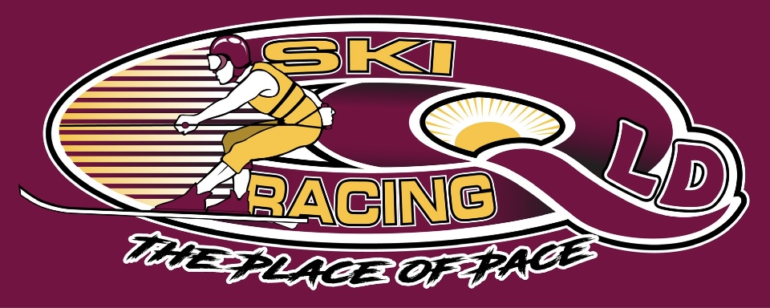
Ski Racing Queensland General Meeting
10th May 2023
Zoom Conference Call

Meeting Opened at 7.38pm

Elected Officers: David McCallum(President), Stewart Smith (Vice President),Debra Opperman (Treasurer), Edwina Best (Secretary), Stewart Smith (SRA Delegate), Chris Singleton(SRA Safety/Development), Scott Cleaver(SRA Race committee)
Brian Shepherd(Safety Officer), Derek Mountney(Marketing),Trophies(Kellie Mountney),Nathan Walker(Development),Todd Loyd(Equipment)

Attendees: Stewart Smith (SS), Jason Davis (JD), Derek Mountney (DM), Todd Lloyd(TL), Chris Singleton(CS),Michael Titmarsh(MT), Scott Cleaver(SC),Rob Low(RL), Nathan Walker(NW), Suzi Cartwright(SC), Brad Haack(BH), Shannon Gray(SG), Debra Oppermann(DO),

Apologies: Edwina Best

Minutes from last meeting April 2023 : Accepted : Chris Singleton
Seconded: Derek Mountney

Business Arising from minutes:
- Electronic Banking to be setup
- NSW State Titles – still not confirmed
- Facebook sites now private groups to avoid spam
- Scott Cleaver Fuel – BP100 Leaded – not allowed, Unleaded/E85/Sunoco allowed
- Fuel Testing being done
- SRA Tier 8 membership now allowed for QLD Competitors
- State Titles now allowed under 1 event fee
- Equipment – MSQ – Surveyor required
- Equipment – Maintenance identified
- SRA Board – Concept of Management – its an agenda item for next meeting
- SRA Rulebook being outsourced

Correspondence In
- mark S - no plans - after Easter
- Seq water - ok Atkinson
- Seq water - 24/25 June - Atkinson
- Scott C - Hervey Bay - June
- Leslie Dam sun water
- NRAC - no to Clarence change
- APBA - Laidley
- Seq water - permit Atkinson
- MSQ - permit Atkinson
- Big river - state title
- MSQ - Leslie feedback

Correspondence Out - May meeting
- Ben Casey - srq calendar update
- Mark stephenson - SRQ dates
- NRAC - change date
- MSQ GC - boat images
- Seq water - Atkinson ok
- Seq water - June claimer
- Sunwater - Leslie Dam
- MSQ - Leslie Dam
- SRA request tier8 confirmation
- APBA - Clarence80 clash
- Cancel Atkinson - seq, MSQ
- Cancel - Leslie

Financial Report – Accepted – Scott Cleaver
Seconded – Derek Mountney
- Available on request
- Electronic Banking to be setup

SRA Race Committee Updates – Scott Cleaver
- Eligibility in classes has been discussed
- Selection races criteria discussed
- Australian crews towing overseas competitors are to be vetted & pathway recommended
- Committee needs an agenda, no items advised beforehand
- Fuel and Drug testing will continue

Race Seeding was discussed with examples called for to be sent to Scott to raise at the next meeting
Experience needs to be on the seeding group
Motion by Stewart Smith – Scott Cleaver to be recommended to go on the SRA seeding group
Seconded by Brad Haack

SRA Safety Committee – Chris Singleton
- 3 x main wetsuit manufacturers have met with SRA
- No Sliding scale for age/flotation
- Document all wetsuits at beginning of season
- Photo in water of wearer and wetsuit

SRA Updates
- SS handling the Worlds - commercial & marketing
- Super series concept for other classes – F70/F80/Juniors/Vets/Masters
- Confirmed for 9-19 November
- 6 teams per country
- No letter yet re Tier 8
- 24th and 25th June – Date request for race at Hervey Bay – TBA
- Clarence 80 date change to 8th & 9th July from 22nd & 23rd July due to clash with Catalina
- Membership – Tier8 and 1 event for State Titles

Judging Updates
- Nil to Report

Safety Updates
- MSQ advised that risk assesments, actions plans and training/induction should be carried out with all safety boat crews

Equipment
- Boat registrations changed from recreational to other categories in line with MSQ requirements for clubs and associations.
- Maintenance requested by MSQ
Small boat
- battery isolator
- Battery cover
- White light
- Red light broken
- Build plate - level flotation
- Maintenance report
- Winch web strap
- Current standard life jackets
- Life jacket standard
- Weld repairs

Large boat
- gurney to identify corrosion
- Build specs on winch
- Under floor flotation
- Repair welds
- Radio
- Side seats - photo flotation
- Max Hp - 100 vs 115
- Stability test - in writing
- Stability test - using winch

Marketing/Media:
Nil to report

Trophies: Derek to chase up
- Chase up Perpetual Trophies – Emma Williams, Ben Gulley, Sean Gardner
- Chae up State Trophies – Cooper Robertson, Emma Barnes

General Business:

Calendar
Mackay Races – 19th & 20th August – Big 2 day event need to support
Mackay races – 11th June, 19th November
Region5 – 3rd & 4th June & 24th & 25th June 2023

Clarence80 – 8th & 9th July 2023
- SRA Sanctioned
- Grand Prix Format – 45min – 1hr
- Maclean/Iluka/Ballina to be investigated by Shannon & Suzi
- 5km course
- Format – World Titles + F70/F80/Vets/Masters/Juniors/Novices

Hervey Bay – 24th & 25th June 2023
- SRA Sanctioned
- In conjunction with Australian Offshore Powerboat Association
- 2 x 45minutes races
- Pool of skiers matched with boats
- Course to be advised
- Switch and compete in 65/80mph offshore classes
- Future plans – Australian Super series/Aquatic events
- Meeting 11th May to discuss further
- Costs involved for off water infrastructure
State Titles
- Combined with NSW still to be advised
- Applications to be handled by EB
- SRA sanctioning to be handled by EB
- Entries through EB
- Format – Mens & Womens x 1 Hour – promote
- Increase lap distance to be discussed
- Food Truck to be approached
- Volunteers – NRAQ
- Jason Davis – Race Director/Controller
- Jason to approach Brian and Kerrie Nutley for safety officer and timing
- Accept entries for ski up not down and no points
- Deb to arrange a float with Jason D
- Live 360 is preferred over race live due to costs
- Costs to be investigated
- Trophies – SS & DM to discuss
- Boat transport for small and large to Grafton

Next General Committee Meeting – 7th June 2023

Meeting Closed at 9.40pm

Minutes Pending Confirmation and acceptance at the next General Meeting

