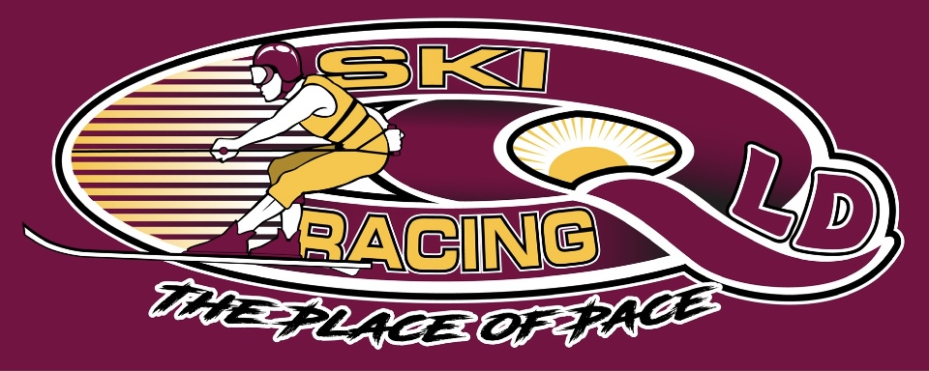
Ski Racing Queensland General Meeting
18th May 2022
Zoom Conference Call

Meeting Opened at 7.38pm

Elected Officers: Stewart Smith (President), Debra Opperman (Treasurer), Edwina Best (Secretary), Jason Davis (Race Director), Scott Cleaver (Commercial), Brian Shepherd (Safety Officer), Richie Terrill (Trophy Officer), Derek Mountney (Marketing & Media)
No VP Role

Attendees: Stewart Smith (SS), Jason Davis (JD),Edwina Best (EB), Chay Woodridge(CW),Brian Shepherd(BS), Derek Mountney(DM), Michael Titmarsh(MT), Colin Hockley(CH), Debra Oppermann(DO), Richie Terrill(RT), Peter Harmer(PH)

Apologies: Nil

Minutes from last meeting 27/4/22: Accepted : Jason Davis
Seconded: Edwina Best

Financial Report –
Current Balance $8308.41
Full report available on request
Outstanding accounts for Wongy Transport
Outstanding income – Somerset and Moogerah
Electronic Banking needs to be discussed to expediate payments

Business Arising from minutes:
- Race committee and board minutes for last 12 months requested via Ben
Casey – still no answer
- Emergency Plans updated and accepted for Moogerah Dam
- EB discussed upgrade for the timing program to Windows 11/Office Pro 16 or 19 – continuing
- SS looking at IT solutions for SRQ – Filing, email, website, software – Update have been advised that Havealook are moving to Outlook 365
- Race Safe negotiated for Southern80
- Nationals not going ahead in 2022
- No correspondence on Nigel Solomans
- Clarence 80 planning underway
- Updated Secretary with Fair Trading completed
- Electronic Banking investigated
- Large Safety Boat to be kept
- EB – MPBC rulebook

Correspondence Inwards:
- APBA shared QLD Calendar
- MSQ Gold Coast requested more information for Moogerah Dam
- Scenic Rim Council confirmed permits for Moogerah Dam
- APBA shared email re use of water September to April each year
- APBA shared email re Yerongapily in Brisbane and use of area
- Moogerah Dam – New manager at Caravan park
- SEQ Water access for Moogerah Dam
- SRA regarding all competitors – Blue Cards
- MPBC updated rule book
- MPBC memberships payment request
- MPBC online membership portal is now Live
- MSQ G/c – Moogerah Dam deed

General Business:

- SRA Update – No updates

MPBC Updates:
- Aug 21 Event in Mackay
- 4 x mph classes each day
- Website going Live
- $1050.00 – 1st Race Memberships
- $980 – 2nd Race memberships
- Ok to include Powerboat classes
- Powerboat brings grassroots
- Development sub committee to create a format for grassroots racing
- Development group to review the rulebook
- Membership change wording of officials to $50

Safety Updates: Nil to report

Equipment Update:
- No SRQ generator ever purchased
- GPS Units to be purchased - $145.00 each – Motion to purchase 6 – SS
2ND – JD

Judging:
- Moogerah and State Titles – No Chief Judge nominated
- Infringements will be managed case by case at Moogerah
- State Titles – JD/BS/ED/Kerrie Nutley will be race committee

Marketing/Media:
- Facebook Reach – 19,119
- Post Engagements – 9250
- New Likes – 41
- Boosted QLD titles – 10,356 reach, 500 Engagements

Trophies for QLD titles:
- Towels embroided
- Chase up Perpetual trophies

Next Management & Event Committee Meeting – July 6th 2022

Next General Committee Meeting – June 15th 2022

Meeting Closed at 9.00pm
Minutes Pending Confirmation and acceptance at the next General Meeting

