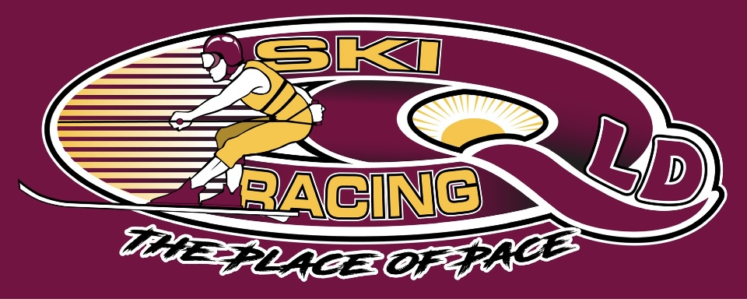
Ski Racing Queensland General Meeting
20th July 2022
Zoom Conference Call

Meeting Opened at 7.30pm

Elected Officers: Stewart Smith (President), Debra Opperman (Treasurer), Edwina Best (Secretary), Jason Davis (Race Director), Scott Cleaver (Commercial), Brian Shepherd (Safety Officer), Richie Terrill (Trophy Officer), Derek Mountney (Marketing & Media), Development - Bevan Garioch (MG) and Michael Titmarsh(MT)
No VP Role

Attendees: Stewart Smith (SS), Jason Davis (JD),Edwina Best (EB), Michael Titmarsh(MT), Debra Oppermann(DO), Richie Terrill(RT),Nathan Walker (NM)

Apologies: Bevan Garioch, Deb Oppermann, Brian Shepherd

Minutes from last meeting June22: Accepted : Edwina Best
Seconded: Jason Davis

Financial Report –
Full report available on request
Current Balance - $17,779.17
State Titles Profit - $6264.00
Outstanding – MPBC Membership - $550.00
Ross Stephenson payment
Big River Ski Club payment
Brian Shepherd – Generator
GPS unit purchase
Breath testing units
Outstanding Income – Entry’s and Memberships - $1150.00
Payments to MPBC total - $4075.00

Finance Meeting Held – SS/JD/DO/EB
Actions:
- Chase up Outstanding’s
- Electronic Banking to be put in place – DO/EB

Business Arising from minutes:
- Race committee and board minutes for last 12 months requested via Ben
Casey – still no answer
- Upgrade for the timing program to Windows 11/Office Pro 16 or 19 – $129/YEAR – Office365
- SS looking at IT solutions for SRQ – Filing, email, website, software – Update have been advised that Havealook are moving to Outlook 365
- Insurance for committee members and volunteers included in the MPBC policy

Correspondence Inwards:
- Big4 Big River Holiday Park - $500 invoice for State Titles
- Big4 Big River Holiday Park - 2023 dates ok for State Titles and Clarence 80
- MSQ Gold Coast event – Advising No
- SEQ water meeting
- Mpbc - insurance coverage
- Quote towels
- Big River - no change to dates requested in August
- Big River - same weekend as previous years – January 2022
- LMSZ - confirm ok, donation, bbq, camping
- Woodburn - ok
- Mpbc 2023 prop

Correspondence Outward:

- Big River Ski Club re 10 September date change
- Big river re 4th September date change
- Seq water - 2022/23 dates
- MSQ GC - October
- Mpbc insurance
- Seq water - back & forth
- APBA re April
- Moogerah ski zone - 13/14 August
- BRSC - Woodburn event in January as he was looking to hold an event prior to Sthn80
- Insurance request
- Permit - Moogerah
- Seq water - ski zone

General Business:

SRA Updates
- Nil to report
- No communication from SRA

Judging Updates
- Nil to Report

Safety Updates
- Nil to report

MPBC Updates:
- Memberships and Entries through MPBC website
- Pay a management fee to SRQ
- $1000 per race cost for insurance
- SS to share MPBC 2022/23 proposal

Equipment Update:
- Breathalyser – Current will expire shortly

Marketing/Media:
- 959 followers
- 166 Gold Coast
- 60 Brisbane

Trophies for QLD titles:
- Towels – obtain a quote for all competitors instead of trophies – SS
- Towels to have Logo, Year and State Titles to all competitors
- Collect trophies – Emma/Sean/Ben –RT to source
- Purchase new
- Currently have State Titles – Fastest Man and Women
- Chase up Scott Cleaver – Perpetuals he will sponsor

Calendar
- Locations – SEQ, Sunwater dams
- 2022/23 dates are locked in and shared with SRA
- Tweed River to be investigated – Nw has relationships with RMS/Police
- Discussed Powerboat racing and interest from Chris Whalen in Iluka

Format:
- 20 races per day
- 2 rounds to be conducted
- No Pointscore

Next General Committee Meeting – August 24th 2022

Meeting Closed at 9.15pm

Minutes Pending Confirmation and acceptance at the next General Meeting

