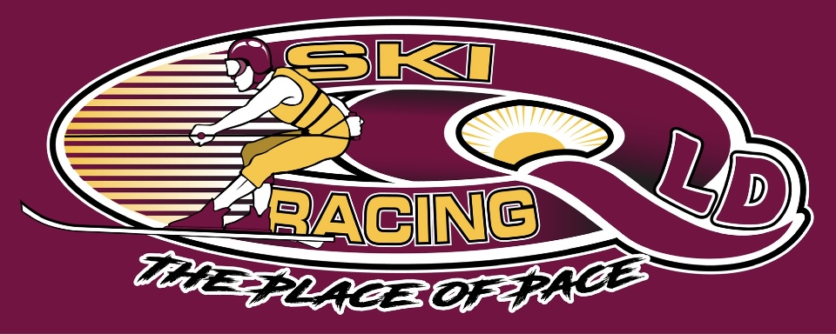
Ski Racing Queensland General Meeting
29th June 2022
Zoom Conference Call

Meeting Opened at 7.30pm

Elected Officers: Stewart Smith (President), Debra Opperman (Treasurer), Edwina Best (Secretary), Jason Davis (Race Director), Scott Cleaver (Commercial), Brian Shepherd (Safety Officer), Richie Terrill (Trophy Officer), Derek Mountney (Marketing & Media), Development - Bevan Garioch (MG) and Michael Titmarsh(MT)
No VP Role

Attendees: Stewart Smith (SS), Jason Davis (JD),Edwina Best (EB),Brian Shepherd(BS), Michael Titmarsh(MT), Debra Oppermann(DO), Richie Terrill(RT), Peter Harmer(PH)

Apologies: Bevan Garioch, Derek Mountney

Minutes from last meeting May 22: Accepted : Jason Davis
Seconded: Edwina Best

Financial Report –
Full report available on request
Reconciliation of income – Somerset, Moogerah, State Titles
Electronic Banking to be discussed to expediate payments in separate finance meeting
SRA Charged $1290.00 for State Titles
Big 4 Big River Ski Park - $500.00 for visitors for weekend – approx. 100 x $5.00 over weekend
Trophies budget to be advised
GPS units to be purchased
Sponsorships and Grants – SS to be started
Payment to Ross Stephenson of $500 for grafton expenses – Motion: SS/2nd EB
Payment to Big River Ski Club of $150.00 for grafton loan boats

Business Arising from minutes:
- Race committee and board minutes for last 12 months requested via Ben
Casey – still no answer
- Emergency Plans updated and accepted for Moogerah Dam
- EB discussed upgrade for the timing program to Windows 11/Office Pro 16 or 19 – continuing
- SS looking at IT solutions for SRQ – Filing, email, website, software – Update have been advised that Havealook are moving to Outlook 365
- Race Safe negotiated for Southern80
- Nationals not going ahead in 2022
- No correspondence on Nigel Solomans
- Clarence 80 planning underway
- Updated Secretary with Fair Trading completed
- Electronic Banking investigated
- Large Safety Boat to be kept
- EB – MPBC rulebook

Correspondence Inwards:
- SEQ Water – BBQ approval for Moogerah Dam
- SEQ Water – advising request for meeting to be advised
- Region5 Letter requesting Clarence 80 date change
- MSQ Permit – Moogerah
- Big River Ski Zone – change 9th & 10th September event
- Moogerah Judges report
- Region 5 – Clarence 80 date
- SRV dates
- SRNSW includes Cliftonville, Region5 Dates
- SRA Dates calendar
- Big River Ski Park – State Titles
- MPBC website – entry website
- NSW Maritime – Clarence 80 permit
- Big River Ski Club – 10th/11th Sept change
- Big4 Holiday Park – Confirming

General Business:

SRA Updates
- Calendar – 2022/23 to be posted
- 2 infringements at State Titles – Demerit Points
- Overspeed infringements were advised
- Name of Boat – Methlab – SRA issue not SRQ or MPBC

Judging Updates
- Congrats to Jason and Brian – Great Job on state titles
- Reconcile – skiers not advising of changes in races
- Comms between skiers and drivers to be addressed at briefing
- All entries to be paid prior to the event
- Do we move to an overall fee
- Boat owner makes payment
- Capped Titles – per boat

Safety Updates
- Titles went well
- Depth of water not an issues
- Run more white bouys on ski park side
- Maintain maritime distances

MPBC Updates:
- July to June policy in place for 22/23
- Proposed SRQ events 6 of 10
- Discuss a flat fee for season
- Paid approx. $5000 for season so far
- Development team presented new format – age & speed with multiple races across the day
- Review race rulebook in line with new format
- Discussed Mackay event attendance – All crews to be asked whether going to determine if SRQ seq event goes ahead

Equipment Update:
- Breathalyser – Current will expire shortly
- Quote for $1828.77 for 2 new units – Motion to purchase SS/2nd by DO
- Decibel meter – 95DBA on course/85dba off course
- GPS units – Motion to Purchase 6 – SS/2nd by DO at $145.00 each
- Radio’s – BS and JD to discuss
- Generator small – Motion to purchase SS/ 2nd by DO - BS to purchase

Marketing/Media:
- Nil to report

Trophies for QLD titles:
- State Titles – Missing 24 x 1st Place – Voted no
- Towels – obtain a quote for all competitors instead of trophies – SS
- Towels to have Logo, Year and State Titles to all competitors
- Photo’s – Voted No

- Perpetual Trophies
- Collect trophies – Emma/Sean/Ben –RT to source
- Purchase new
- Currently have State Titles – Fastest Man and Women
- Chase up Scott Cleaver – Perpetuals he will sponsor

Calandar
- August event at Somerset
- Septmeber event at Atkinson
- October event – TBA
- SS to work on 2022/23 dates and locations
- Big River request to change the 10th/11th Date – Proposed that we combine and if not combined SRQ keep the date
- Tweed River discussed – Stand alone events rather than work with Tweed River Ski Club

Next Management & Event Committee Meeting – July 6th 2022

Next General Committee Meeting – July 13th 2022

Meeting Closed at 10.00pm
Minutes Pending Confirmation and acceptance at the next General Meeting

