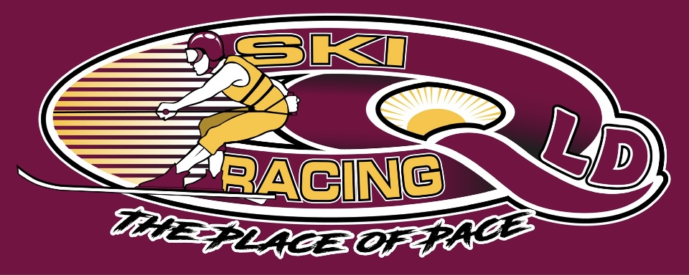
Ski Racing Queensland General Meeting
5th April 2023
Zoom Conference Call

Meeting Opened at 7.45pm

Elected Officers: David McCallum(President), Stewart Smith (Vice President),Debra Opperman (Treasurer), Edwina Best (Secretary), Stewart Smith (SRA Delegate), Chris Singleton(SRA Safety/Development), Scott Cleaver(SRA Race committee)
Brian Shepherd(Safety Officer), Derek Mountney(Marketing),Trophies(Kellie Mountney),Nathan Walker(Development),Todd Loyd(Equipment)

Attendees: David McCallum(DM), Stewart Smith (SS), Jason Davis (JD), Derek Mountney (DM), Todd Lloyd(TL), Chris Singleton(CS),Michael Titmarsh(MT), Edwina Best(EB), Scott Cleaver(SC),Rob Low(RL)

Apologies: Debra Oppermann(DO), Brian Shepherd(BS), Nathan Walker(NW)

Minutes from last meeting March 2023 : Accepted : David McCallum
Seconded: Chris Singleton

Business Arising from minutes:
- Electronic Banking to be setup

Correspondence In:
- MSQ feedback on rego & wetsuits – requirements of Risk Plans
- Receipt of Atkinson Fee
- MPBC rule book / Edwina reviewed
- MSQ wetsuits/life jackets - Rulebook accepted
- MSQ - boats Safety Management Plans required
- NSW combined titles ask by Alan France
- MSQ - Somerset Council rules
- Kerrie Nutley - entry state title process can be setup
- MSQ GC - boat specs - crane red flag
- Board - new social rope length to be unrestricted
- Board - Barry Carne change of date and background
- NSW state titles - sharing

Correspondence Out
- NSW confirming combined state titles - call a meeting
- Big River Holiday Park - confirming State Titles
- Peta smailes re Facebook sites
- Yamba Welding - boat specs for the large Punt

Financial Report – Accepted – Chris Singleton
Seconded – Derek Mountney
- Available on request
- Electronic Banking to be setup

SRA Race Committee Updates – Scott Cleaver
- Rope Lengths for social Unrestricted – Voted Yes by QLD on safety
- Southern80 Timing discrepancies on the Saturday, not addressed by Moama
- Explanation of issues which occurred with competitors at the Southern80 – Judicial in progress
- Super Class Nominations for a competitor from Driver to Observer – Observed the process is not working correctly by the race committee and needs to be addressed to ensure that there are steps to meet a class criteria.
- Concussion and how to manage is on the table for discussion
- Fuel Testing to be done at Mildura – Costly.
- Drug Testing – process was not correct
- Recommend more drug testing
- Fuel is an issue for some competitors due to engine issues, SC to raise as an issue at the race committee and have BP100 accepted as a fuel of choice.
- Edwina raised the point that judges are not being included for input on rules

SRA Safety Committee – Chris Singleton
- Discussion on the new rules for wetsuits – Colour rules being implemented
- Discussion on the new recommendations for wetsuit flotation
- December 2023 is implementation date
- Concerns raised from QLD on these recommendations based on feedback from local manufacturer and the changes in legislation
- Driver and observer jackets need to be reviewed regarding legislation and conditions
- CS raised that the legislation comes from a swimmers perspective if a skier or crew are in the water
- SC raised visibility of skiers when not wearing a helmet after a fall, visibility

SRA Updates
- SS handling the Worlds - commercial & marketing
- Super series concept for other classes – F70/F80/Juniors/Vets/Masters
- Confirmed for 9-19 November
- 6 teams per country
- Meetings calendar to be developed
- Dates for next year discussed
- Update to SRQ calendar
- No letter yet re Tier 8
- 24th and 25th June – Date request for race in SEQ
- Clarence 80 date change to 8th & 9th July from 22nd & 23rd July due to clash with Catalina
- Focus on tier 8 and then case by case to do state titles & classic

Judging Updates
- Nil to Report

Safety Updates
- MSQ advised that risk assesments, actions plans and training/induction should be carried out with all safety boat crews
- Boat scrutinnering to be carried out at Atkinson Dam including crew equipment
- Skier scrutineering - wetsuits and helmets to be conducted in line with SRA rules

Equipment
- Boat registrations changed from recreational to other categories in line with MSQ requirements for clubs and associations.
- Spill kits to be discussed to be purchased at a later stage
- 15th April – equipment check day
- Surveyor – KPS Surveying – Photo/Form/Online assessment/Plate

Marketing/Media:
Nil to report

Trophies:
- Chase up Perpetual Trophies – Emma Williams, Ben Gulley

General Business:

State Titles
- Combined with NSW
- Applications to be handled by EB
- SRA sanctioning to be handled by EB
- Entries through Kerry Nutley – My Form
- Bank account and Pay Pal to be setup by SS
- In writing arrangement
- Split all takings 50/50 after expenses
- Expenses to include costs of equipment used

Lake Atkinson Planning
- Entries need to be entered by 12th April
- No Kiosk or fuel at the Dam
- SEQ water and MSQ are processing permits
- Course setup Saturday from 12pm – all hands on deck – SS to lead
- CS to contact the Caravan Park to ask re BBQ/equipment and camping
- BBQ to be bring your own – food and drink
- Saturday is a ski and scrutineer afternoon
- SS to notify businesses
- EB to advise local paper with Advert
- Banners to each gate to be put in place
- Trophies for next gen – DM to arrange
- Format to be determined after entries
- Rob Low feedback on format re skiers in all races and needs
time
- Race Director/Controller is Jason Davis
- Transports boats to Atkinson – Large Boat ??, small boat – CS, Haines-SS, 1 extra boat

Actions List
Scott Cleaver – Fuel at race committee
Stewart – Concept of management for wetsuits and concussion – Board
Stewart – 24th & 25th June – SRQ Race meet – Selection race format
Stewart – Letter confirming Tier8 from SRA
Stewart – change Clarence80 date to 8th & 9th July due to clash with Catalina
Stewart – communicate date change to NRAC
Stewart – change calendar
Stewart – Atkinson – BBQ and Saturday plans
Stewart – Surveyor
Stewart – setup Pay pal account
Stewart – checking in with SEQ water and MSQ
Stewart – Promote Atkinson Saturday and details of BBQ
Stewart – Notify local businesss
Stewart – Ad for paper
Stewart – Banner at gates
Todd – Boat transport
Todd – Equipment sorting
Stewart – Extra Boat
Edwina – Local newspapers
Chis S – Helmets/D Clips/Wetsuit Flotation/Helmets re visibility – Safety committee
Edwina – Scrutineering forms to be sent to stewart for completion on the 15th April

Next General Committee Meeting – 10th May 2023

Meeting Closed at 9.37pm

Minutes Pending Confirmation and acceptance at the next General Meeting

