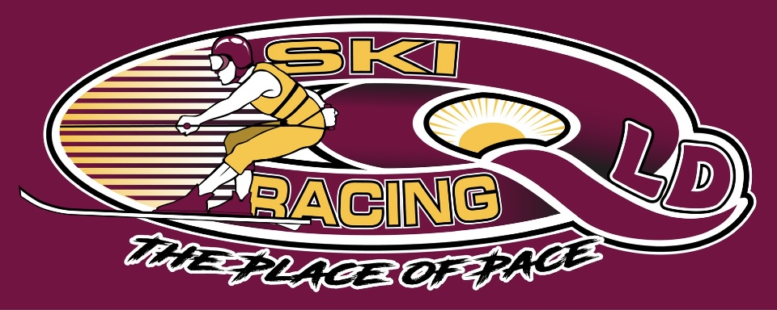
Ski Racing Queensland General Meeting
19th January 2022
Zoom Conference Call

Meeting Opened at 7.00pm

Elected Officers: Stewart Smith (President), Darren Apps (Vice President), Debra Opperman (Treasurer), Amy Hockley (Secretary), Jason Davis (Race Director)

Attendees: Stewart Smith (SS), Darren Apps (DA), Jason Davis (JD), Debra Oppermann (DO), Edwina Best (EB), Bevan Garioch (BG), Scott Cleaver (SC), Rory Medway(RM), Derek Mountney (DM), Peter Harmer (PH), Nathan Walker(NW), Grant Titmarsh (GT), Michael Titmarsh (MT), Craig Murphy(CM)

Apologies: Amy & Col Hockley, Brian Shepherd, Richie Terrill

Minutes from last meeting 7/12/21: Accepted Stewart Smith
Seconded Darren Apps

Business Arising from minutes:
- All 2022 dates have been advised to SRA for updating into the SRA calendar
- Moogerah Dam permits submitted for 30th January
- Somerset Dam permits submitted for 27th February
- Bundaberg Permits submitted for 12th & 13th March
- Discussion ongoing for Leslie Dam & Coolmunda Dams with MSQ and Sunwater
- Clarence 80 – Grafton and Qld State Titles – being investigated
- Race committee and board minutes for last 12 months requested via Ben Casey – no answer
- Jon Horbury has agreed with SS that he is ok with SRQ Management Team reviewing once received
- MPBC Rulebook – reviewed and accepted
- Buoys purchased – delayed until 25th January
- Trophies – Thank you to Peter Harmer for donation to be rebadged and reused

Treasurers Report:
- See Attached

Correspondence:
- SEQ Water – Approved Permits for Moogerah received
- MSQ Qld – Approved Permits for Moogerah received
- SEQ Water – Somerset permit feedback
- MSQ Qld – Somerset permit feedback
- Sunwater – To advise Bundaberg not their waterway so MSQ
- Covid Plan feedback from MPBC – Not required
- LMWSZ – Advising that due to Covid restrictions will not allow access for the 30/1/22, Will continue dialogue for September event
- Club Rulebook reviewed and confirmed by MPBC
- MPBC forms all completed
- SRQ Waiver completed
- MOU signed between MPBC & SRQ
- Lake Moogeragh Caravan Park confirming access for the 29th & 30th January
- SEQ Water – Requested update on risk assessment and planning maps for on land requirements for 30/1/22
- SEQ Water advised that they had received a push back on allowing a permit due to extension of school holidays. Currently at 19/1/22 still allowable
- Risk Assessment for crews and skiers being developed by SRQ – Received from SRA the ACT version
- SS has been in initial discussions with SRA – Tim Horbury re alternative income streams which include a Loyalty Program for members, business networking group and a National Super Series.

General Business
- Grant Application period for QLD Government has been delayed due to Covid, SS working on submissions and grants available
- Spill Kit required under risk assessment submitted
- Deb O to check with Mark O to borrow for Moogerah
- SRQ to investigate purchasing a spill kit – Col Hockley
- Deb O asked if a Covid Plan is required for Moogerah – Our understanding is no Covid Plan is required and check in at the camping ground will be in place
- Deb O advises the Breathalyser should be back from calibration
- Bouys are behind on delivery schedule – decided that we will run Moogerah with what we have
- 2 Day race meetings to be half day of racing each day, Formats open for discussion
- North Queensland have reached out to investigate how to get racing going in Townsville and Cairns – ongoing discussions and have explained the MPBC model vs the SRA Model, encouraged to come to Bundaberg
- Offshore QLD series is an idea being discussed with the Development team for 2023.
- Request to SRA has been submitted for Coolmunda Dam, Clarence 80 and State Titles with SRA for Certificate of Currency – No answer at this time (JD)
- Permits for Clarence 80 and State Titles at Big River are to be submitted by Edwina, as they are on line applications require all paperwork
- SC asked re the MPBC fees paid in 2021, BG advised that as it is a calendar year membership that would need to pay the $50 per boat and $50.00 per member for 2022.
- SC/JD/PH/SS/Nathan Cleaver/Ben Clark/Nathan Goodall all paid at the 2021 event.

Moogerah Dam Discussion
- New attendees were invited to provide feedback on the MPBC program and all were in favour of the vision for the events
- SS explained that all forms are now online at the SRQ website
- SS stated should encourage all enquires to sign up for the newsletters to stay up to date
- Switch of venue from ski zone to caravan park is currently with SEQ Water to confirmation
- Discussion around new crews and how we will work with them to get racing
- Entries and membership paperwork have been slow coming in – All encouraged to push to have entries in by the 25th January.
- Cash Float and Credit Card Facilities to be arranged – Stewart Smith & Debra Opperman
- All crews expected to provide a helper during the day
- Edwina to contact SRA for a members list to cross check SRA members competing at Moogerah
- Setup to commence 29th January from midday
- Officials for Moogerah:
Chief Officials - Stewart Smith and Brad Nelson (MPBC)
Race Director – Jason Davis
Race Controller – Darren Apps
Safety Officer – Darren Apps
- Entries – Encourage entries in before the day
- Entry paperwork on the day creates issues that will require additional resources
- Additional resources to be allocated if required
- All to encourage boats and crews to compete, with social media, EDM’s and phone calls to be ramped up this week

Next General Committee Meeting – February 16th 2022

Next Management Committee Meeting – February 9th 2022

Meeting Closed at 8pm

Minutes Pending Confirmation and acceptance at the next General Meeting

