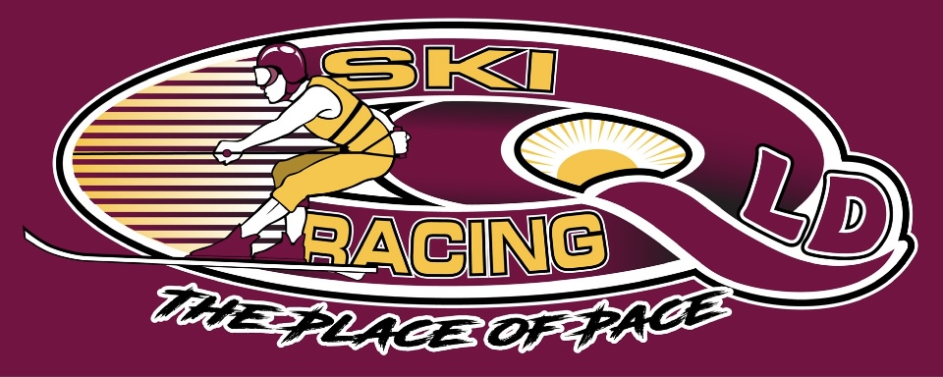
Ski Racing Queensland General Meeting
23rd March 2022
Zoom Conference Call

Meeting Opened at 7.00pm

Elected Officers: Stewart Smith (President), Darren Apps (Vice President), Debra Opperman (Treasurer), Amy Hockley (Secretary), Jason Davis (Race Director), Scott Cleaver (Commercial)

Attendees: Stewart Smith (SS),Debra Oppermann (DO), Jason Davis (JD),Edwina Best (EB), Darren Apps (DA),Colin Hockley (CH), Amy Hockley (AH), Richie Terrill(RT), Craig Murray (CM)

Apologies: Nil

Minutes from last meeting 16/2/22: Accepted – Edwina Best
Seconded Jason Davis

Treasurers Report: Received and Approved – EB/Seconded SS

Business Arising from minutes:
- All 2022 dates have been updated with SRA
- Nil correspondence from MPBC regarding complaint from Moogerah race
- Sanctioning fees received from SRA
- SRA have sanctioned Clarence 80 and QLD state titles
- Updated Moogerah Dam aquatic zone received from MSQ
- Race committee and board minutes for last 12 months requested via Ben
Casey – no answer
- Big River Ski Park - Permission granted for Clarence 80 & State Titles

Treasurers Report:
- MPBC Payment made for Memberships and Boat Fee’s - $2750.00
- Event costs are being covered by entries
- Costs to bring SRQ back up to spec are seeing funds being used.

Correspondence:
- SRA Sanction fees letter
- Derek Moutney – Peter Christians Family have suggested a cash donation for a “Spirit Award”, Family to set the criteria, suggested that instead of cash equipment could be purchased for the winner
- MSQ Bundaberg – Permit feedback of approved with transit lane
- MSQ Sunshine Coast – confirming Somerset cancellation due to flood
- SEQ water – confirming Somerset cancellation due to flood
- SEQ Water – confirmation of a new date
- MSQ Gold Coast – Police have requested Emergency Plans to be updated for Moogerah
- MSQ Gold Coast – Have confirmed new aquatic license map being gazeeted
- MSQ Bundaberg – Postponed until 19th & 20th Nov with a new fee
- Edwina Best resignation from Race committee
- Ben Casey acceptance of resignation of EB
- SRA requested that SRQ advise any competitors competing in MPBC sanctioned events that they are not SRA events
- SRA requested that non SRA events in calendar be marked accordingly
- Big River Ski Park Approval for State Titles and Clarence 80

General Business
- EB discussed upgrade for the timing program to Windows 11/Office Pro 16 or 19
- SS looking at IT solutions for SRQ – Filing, email, website, software
- CH to check the container at East Coast and remove items required
- Discussion on Moogerah ski zone vs Campground – preferred camp ground due to access for spectators
- Grafton and SRQ are separate entities, advised to SRA in writing
- Demerit Points – How being communicated to States(JD)
- SRA require 700 members to join
- SRQ to request a grassroots package for members (SS)
- Victoria are pushing back on grassroots and lower levels of cover
- SRQ recommendation to race committee of makeup – State Delegate & 1 guest per state plus 1 judging delegate(SS)
- SRQ recommendation for seeding committee – State Rep + 1 guest (SS)
- Nominations for SRQ – Col Hockley, Richie Terrill/Jason Davis – Nominated SS
- Discussion took place on Nigel Soloman – Hook vs Spin vs mechanical
- Mark Oppermann to discuss with Andrew Donahue re scrutineering of twin rigs

Next Management & Event Committee Meeting – April 4th 2022

Next General Committee Meeting – April 20th 2022

Meeting Closed at 9.30pm
Minutes Pending Confirmation and acceptance at the next General Meeting

